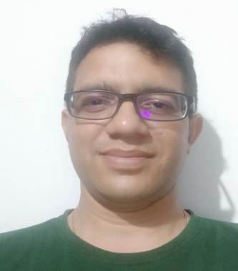
MONURANJAN KALITA
MCA, M-PHIL

Address :
C/O. Late H.N. kalita
P.O. Arjunguri, Ward No. 07
Sivasagar, Assam
Pin. : 785697
Contact No. 91013-88703 / 7896189735 ( WhatsApp)
Joining to Amguri College: 04-04-2012 ( NS)

Experiences :

- External Examiner of the HS Final Examination 2013 ( Practical)

- External Examiner of the HS Final Examination 2015 ( Practical)

- External Examiner of the BA 3rd and 5th Semester Examination 2015 ( Practical)

- External Examiner of the BA 3rd and 5th Semester Examination 2016 ( Practical)

- External Examiner of the B.Sc. 6th Semester Examination 2017 ( Practical)

- External Examiner of the B.Sc. 2nd Semester and B.Sc. 4th Examination 2017 ( Practical)

- Head Examiner in the B.Sc. 2nd Semester exam 2017

- External Examiner of the B.Sc. 6th Semester Examination 2017 ( Practical)

- External Examiner of the HS Final Examination 2018 ( Practical)

- External Examiner of the BA 3rd and BA 5th Final Examination 2019 ( Practical)

- External Examiner of the BA 4th and BA 6th Final Examination 2019 ( Practical)

- External Examiner of the HSLC final Examination 2020 ( Practical)

- Head Examiner in the B.A. 3rd Semester exam 2020

Workshop : Participated in the National Workshop on Community College: Desired Model for India , Tezpur University, Assam

Book Published : “ A text Book on Computer Skill “ For BA 3rd Semester
Published By : Bonolota
ISBN Number : 93-82750-47-5

