PERSONAL PROFILE

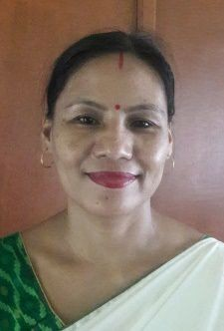
Name :- RATNA MONI KONWAR
Date of Birth :- 08 April 1978
Sex :- Female
Address :- C/o Dr. Basanta Kr. Gogoi
Village/ Town :- Amguri Town College Tiniali
Ward No. :– 6
P.O. :- Amguri Pin :-785680
Dist. :- Sivasagar
Designation : Assistant Professor

Department of Political Science.
Language Known: English, Hindi, Assamese
Phone :- 8876283245
Email :- konwarratnamoni@gmail.com
Educational Qualification :-

Exam. Passed | Board/ Council/ University | Year of Passing
M.A. | Dibrugarh University | 2003
M. Phil. | Dinayak University, Tamil Nadu | 2008
B.A. | Dibrugarh University | 2000
H.S. | AHSEC | 1996
H.S.L.C | SEBA | 1994

TECHNICAL SKILIS :-

: MS Office

BIOGRAPHY

Mrs. Ratamoni Konwar was born 8th April 1978 in Sivasagar, Assam. She completed her HSLC from Amguri Girls High School, Amguri, Sivasagar. She completed Bachelor of Arts (B.A.) with honors in Political Science from Jhanji Hemnath Sharma College 2000. During College time She was actively associated in college activities. She also passed Master of Arts (M.A.) in Political Science from Dibrugarh University in 2003.
After completing Master Degree she has been Serving at Amguri College as an Assistant professor, Department of Political Science. She Joined the college on the 1st of August 2003. She has been associated with all activities of department and College.
She has actively participated and attended National Seminars and Workshops on different occasions .

National Seminar :-
- “Society and culture of Foothill Tribes of North-East India- Change and continty at Amguri College.
- “Youth Unrest and Agitations its trends in present Society” organza by Jhangi College, Jhanji -2003.
- “Implementation of Social Welfare Schemes in India with Special reference to Assam : issues and challenge organized by Amguri College, Amguri- 2013.

National Level Workshop :-
- Domestic Vilence Act, 2005 : its uses and misuses organized by women cell, Amguri College, 2005.
- Environment conversation, organized by Eco club Amguri College, Amgui 2015.
- MOOCs – SWAYAM and OER organized by IQAC, Amguri College, Amguri. 2019.

ACHEVEMENTS :-
: National Seminar.
: Literacy Activities such as Article.

